**Chapter 13 AD-AS Questions**

**1. The aggregate demand curve illustrates the**

* 1. positive relationship between the price level and the quantity demanded of real gross domestic product (GDP).
  2. positive relationship between the price level and the quantity demanded of nominal GDP.
  3. inverse relationship between the price level and the quantity demanded of real GDP.
  4. inverse relationship between the price level and the quantity demanded of nominal GDP.
  5. positive relationship between the level of spending and the level of real GDP.

**2. The aggregate demand curve slopes downward because**

* 1. as price falls, consumers substitute more expensive goods for less expensive goods.
  2. the demand curves of individual markets slope downward.
  3. a lower price level decreases purchasing power.
  4. a lower price level decreases exports.
  5. a lower price level increases real wealth.

**3. When the price level rises, ________ declines from the wealth effect, ________ declines from the interest rate effect, and ________ decline(s) from the international trade effect.**

* 1. consumption; investment; net exports
  2. consumption; consumption; consumption
  3. investment; investment; net exports
  4. investment; consumption; net exports
  5. investment; investment; investment

**4. The interest rate effect results from people**

* 1. saving less when the price level rises.
  2. consuming more when the price level rises.
  3. spending more when the interest rate rises.
  4. feeling wealthier when the price level rises.
  5. spending less when the price level falls.

**5. According to the interest rate effect, an increase in the price level leads to ________ in the interest rate, and therefore to ________ in the quantity of aggregate demand.**

* 1. no change; no change
  2. a rise; a fall
  3. a rise; a rise
  4. a fall; a fall
  5. a fall; a rise

**6. When the price level rises and U.S. goods become relatively more expensive than foreign goods, there will be a(n)**

* 1. rightward shift of the aggregate demand curve.
  2. leftward shift of the aggregate demand curve.
  3. upward movement along the aggregate demand curve.
  4. downward movement along the aggregate demand curve.
  5. downward movement along the aggregate supply curve.

**7. An increase in the value of the dollar will**

* 1. have no effect on aggregate demand or supply.
  2. increase exports.
  3. reduce imports.
  4. increase aggregate demand.
  5. decrease aggregate demand.

**8. Which of the following would shift aggregate demand to the left?**

* 1. Firms increase production.
  2. There is a decline in consumer confidence.
  3. Stock market values increase by 20%.
  4. A fall in the price level increases the value of real wealth.
  5. Net exports increase.

**9. Aggregate supply describes the**

* 1. willingness and ability of consumers to purchase what is supplied.
  2. willingness and ability of suppliers to produce gross domestic product (GDP).
  3. relationship between suppliers’ costs and revenue.
  4. relationship between suppliers’ spending and output.
  5. willingness and ability of consumers to supply labor to firms.

**10. Which of the following is true?**

* 1. Long-run aggregate supply is independent of the price level.
  2. Short-run aggregate supply is independent of the price level.
  3. Long-run aggregate supply is positively related to the price level.
  4. Short-run aggregate supply is inversely related to the price level.
  5. Long-run aggregate supply is inversely related to the price level.

**11. What can cause a shift in the long-range aggregate supply (LRAS)?**

* 1. a change in labor productivity
  2. a change in wealth
  3. supply shocks
  4. a change in foreign spending
  5. the interest rate effect

**12. An increase in the workforce can be expected to**

* 1. increase long-run aggregate supply (LRAS).
  2. increase the price level.
  3. increase wages.
  4. decrease aggregate demand (AD).
  5. decrease aggregate supply (AS).

**13. Which of the following would cause an increase in long-run aggregate supply?**

* 1. The price level increases.
  2. The price level decreases.
  3. Firms and workers expect the price level to fall.
  4. Firms and workers expect the price level to rise.
  5. The amount of physical capital increases.

**14. If the price level rises by 5%, then, all else being equal, the long-run quantity of aggregate supply (LRAS) will**

* 1. increase by 5%.
  2. decrease by 5%.
  3. not change.
  4. increase by more than the short run aggregage supply (SRAS).
  5. increase by an indeterminate amount.

**15. Increases in productivity will**

* 1. cause the price level to rise.
  2. impact short-run aggregate supply (SRAS) but not long-run aggregate supply (LRAS).
  3. impact aggregate demand (AD) but not aggregate supply (AS).
  4. increase LRAS.
  5. increase the price level and AS.

**16. When inflation pushes up prices in the economy, input prices are ________ and revenues ________ in the short run.**

* 1. flexible; remain unchanged
  2. sticky; increase
  3. sticky; remain unchanged
  4. flexible; decrease
  5. flexible; increase

**17. How can we explain the slope of the short-run aggregate supply (SRAS) curve?**

* 1. It is highly elastic because all prices are sticky in the short run.
  2. It is positive because of sticky input prices and flexible output prices.
  3. It is negative because of flexible input prices and sticky output prices.
  4. It is vertical because all prices are flexible in the short run.
  5. It is positive because all prices except wages are flexible in the short run.

**18. Menu costs help explain**

* 1. the negative slope of the aggregate demand (AD) curve.
  2. the negative slope of the aggregate supply (AS) curve.
  3. the positive slope of the short-run aggregate supply (SRAS) curve.
  4. why the long-run aggregate supply (LRAS) curve is vertical.
  5. why the LRAS curve is horizontal.

**19. If the price level falls but workers are reluctant to accept a pay cut, this is an example of**

* 1. menu costs.
  2. money illusion.
  3. irrational thinking.
  4. opportunity costs.
  5. incentives.

**20. A decrease in the general price level will lead to**

* 1. a downward movement along the short-run aggregate supply (SRAS) curve as firms decrease output.
  2. a rightward shift of the SRAS curve as firms increase output to make up for lost profits.
  3. a leftward shift in long-run aggregate supply (LRAS) as firms decrease output.
  4. a leftward shift of the SRAS curve as firms decrease output.
  5. no change in the SRAS because of money illusion.

**21. Which of the following would affect both short-run (SRAS) and long-run aggregate supply (LRAS)?**

* 1. the unemployment rate
  2. a change in labor costs
  3. money illusion
  4. technological changes
  5. the rate of inflation

**22. If inflation turns out to be higher than expected, this will**

* 1. shift long-run aggregate supply (LRAS) to the right.
  2. shift LRAS to the left.
  3. shift short-run aggregate supply (SRAS) to the left.
  4. shift SRAS to the right.
  5. cause movement along the short-run aggregate supply curve.

**23. For the aggregate demand (AD), short-run aggregate supply (SRAS), and long-run aggregate supply (LRAS) to intersect at the same place, the economy would have to be operating**

* 1. below the natural rate of unemployment.
  2. above the natural rate of unemployment.
  3. below the full-employment level.
  4. at the full-employment level.
  5. above the full-employment level.

**24. How will the economy move toward long-run equilibrium on its own?**

* 1. The level of wealth will change.
  2. The price level will adjust.
  3. Congress will increase government spending.
  4. The productive capacity of firms will remain stable.
  5. The full-employment output level will change.

Refer to the following graph to answer the next 3 questions.  
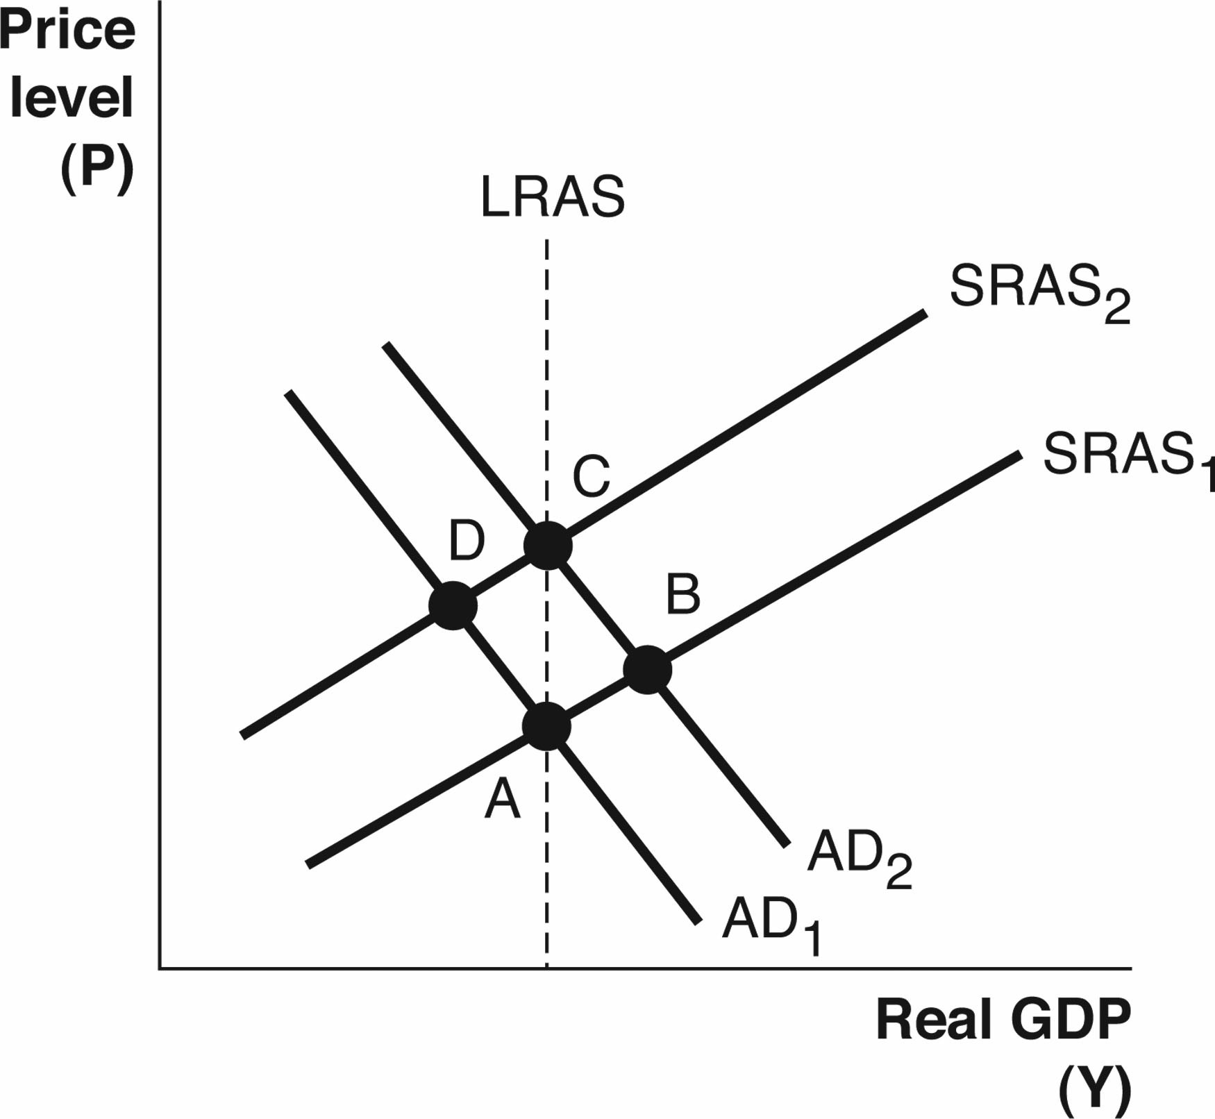

**25. Based on the graph, which Points represent short-run equilibrium but not long-run equilibrium?**

* 1. A and B
  2. A and C
  3. A and D
  4. B and D
  5. A, B, C, and D

**26. Based on the graph, a decrease in ________ could cause the economy to move from Point A to Point B.**

* 1. the price level
  2. consumer confidence
  3. the labor force participation rate
  4. wages
  5. taxes on consumers

**27. Based on the graph, a decrease in ________ could cause the economy to move from Point D to Point A.**

* 1. government spending
  2. restrictions on immigrant labor
  3. the demand for consumer goods
  4. exports
  5. inflation

**28. If wildfires burned 25% of California's physical capital, then long-run output will ________ and the price level will ________.**

* 1. decrease; decrease
  2. decrease; increase
  3. decrease; remain unchanged
  4. remain unchanged; remain unchanged
  5. remain unchanged; increase

**29. Suppose a country’s population is aging and the size of the workforce is declining. In the long run, output will ________ and the price level will ________.**

* 1. decrease; increase
  2. remain unchanged; decrease
  3. decrease; decrease
  4. decrease; remain unchanged
  5. increase; decrease

**30. Suppose a country’s population is growing due to immigration. In the long run, output will ________ due to ________.**

* 1. increase; an increase in short-run aggregate supply (SRAS)
  2. increase; an increase in long-run aggregate supply (LRAS)
  3. increase; an increase in aggregate demand (AD)
  4. decrease; an increase in the price level
  5. decrease; labor costs increasing

Refer to the following graph to answer the next two questions.  
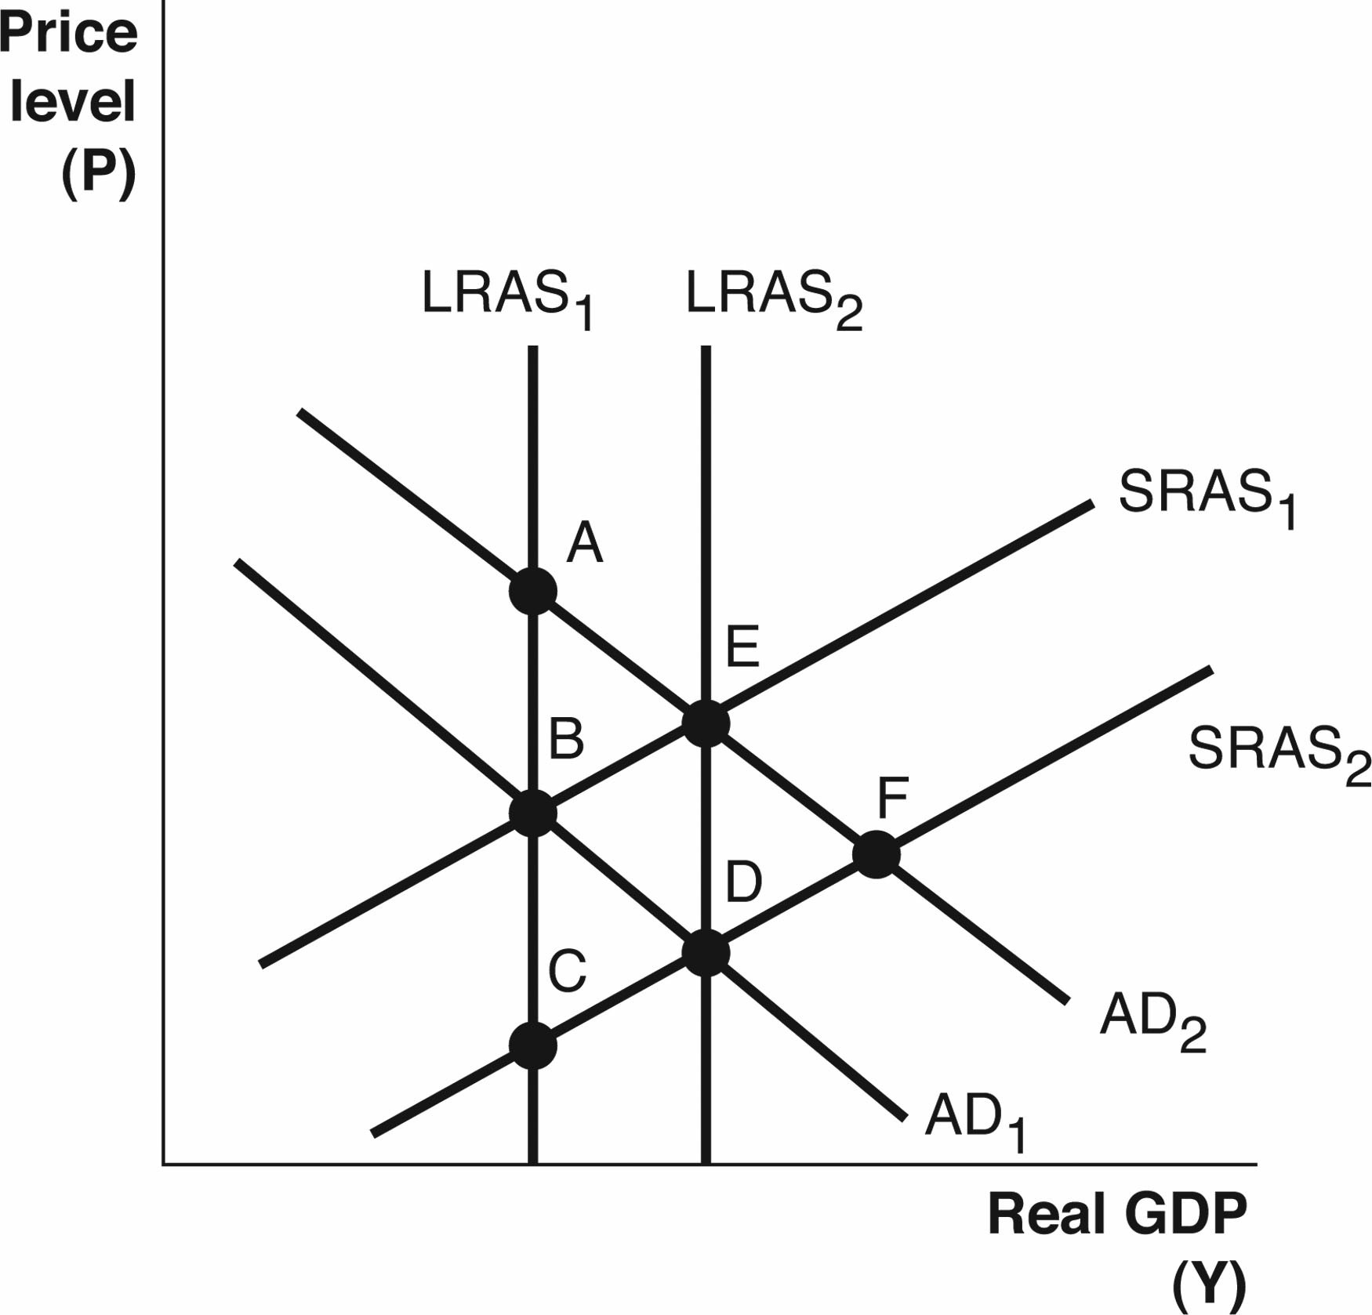

**31. Based on the graph, which of the following would cause the long-run equilibrium point to change from Point B to Point D?**

* 1. The retirement age has decreased resulting in fewer people in the labor force.
  2. Firms and workers expect the price level to rise.
  3. Government spending decreases.
  4. A negative supply shock has occurred.
  5. The country’s overall productivity increased.

**32. Based on the graph, which of the following would cause the aggregate demand (AD) curve to decrease from AD2 to AD1?**

* 1. The economy has been producing more than its full-employment output level, and wages and input prices begin to rise.
  2. There is an increase in the price of oil.
  3. There is an increase in the general price level that reduces real wealth.
  4. There is a reduction in consumer confidence about future growth in the economy.
  5. There is a reduction in income tax rates.

**33. If short-run equilibrium output is below full-employment output, then, in the long run, input prices will**

* 1. decrease and output will increase.
  2. be unaffected and output will increase.
  3. increase and short-run aggregate supply (SRAS) will increase.
  4. increase and output will decrease.
  5. decrease and output will also decrease.

**34. A new method of farming is developed that increases output by one-third. This will impact**

* 1. short-run aggregate supply (SRAS).
  2. SRAS and long-run aggregate supply (LRAS).
  3. LRAS.
  4. aggregate demand (AD).
  5. SRAS and AD.

**35. If the current short-run equilibrium level of output is greater than full-employment output, we can expect that in the long run the**

* 1. price level will rise and short-run aggregate supply (SRAS) will decrease.
  2. price level will rise and aggregate demand (AD) will decrease.
  3. price level will fall and SRAS will increase.
  4. price level will fall and AD will increase.
  5. long-run aggregate supply (LRAS) will increase.

**36. Mexico and the United States are trading partners. If wealth increases in Mexico, then, in the short-run, equilibrium output in the United States will ________ and the price level will** ________.

* 1. increase; increase
  2. decrease; decrease
  3. remain unaffected; remain unaffected
  4. decrease; remain unaffected
  5. increase; remain unaffected

**37. Suppose there is a surge in stock market values. In the short run, we would expect the price level to ________ and the unemployment rate to ________.**

* 1. increase; decrease
  2. increase; increase
  3. decrease; increase
  4. decrease; decrease
  5. remain unchanged; decrease

**38. Suppose housing values fall during a recession. In the short run,**

* 1. the price level will fall as we move down the aggregate demand (AD) curve.
  2. the price level will fall as the aggregate demand (AD) curve shifts left.
  3. SRAS will decrease and the price level will fall.
  4. SRAS will increase because wages will fall.
  5. AD will increase because the demand for houses will increase.

Refer to the following graph to answer the next three questions.

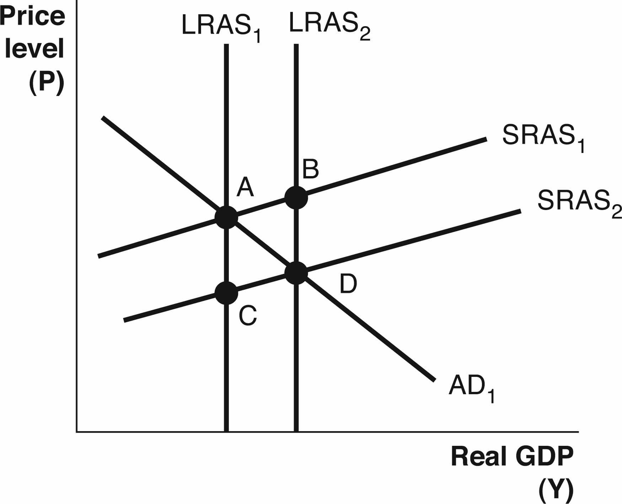

**39. Based on the graph, a positive supply shock is best represented by a movement from**

* 1. LRAS1 to LRAS2.
  2. SRAS2 to SRAS1.
  3. SRAS1 to SRAS2.
  4. LRAS2 to LRAS1.
  5. LRAS2 to LRAS1 and SRAS1 to SRAS2.

**40. Based on the graph, which of the following would cause the short-run aggregate supply (SRAS) curve to shift from SRAS2 to SRAS1?**

* 1. Congress votes to decrease the minimum wage.
  2. There is an increase in spending and firms respond by producing more output.
  3. Wages and input prices rise as the economy responds to inflation expectations.
  4. The number of people in the workforce increases.
  5. A temporary fall in the price of oil results in lower gasoline prices.

**41. Based on the graph, which of the following could cause a shift from LRAS1 to LRAS2?**

* 1. an improvement in the stock market (wealth)
  2. an improvement in technology
  3. an increase in wages
  4. a decrease in the price level
  5. a recovery from a recession

Refer to the following graph to answer the next three questions.

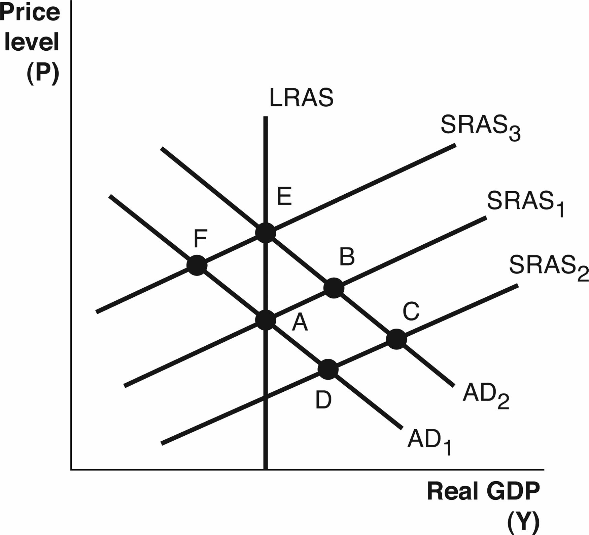

**42. Based on the above graph, starting at Point A, if there is an increase in government spending, then in the short run, we would move to Point ________ and in the long run to Point ________.**

* 1. B; E
  2. B; C
  3. D; A
  4. D; C
  5. B; A

**43. Based on the above graph, starting at Point A, if there is an increase in the price of oil, then in the short run, we move to Point ________ and in the long run to Point ________.**

* 1. F; E
  2. F; A
  3. D; C
  4. D; A
  5. B; E

**44. Based on the above graph, if the economy is currently at Point B, then, in the long run, we can expect the economy to naturally adjust to Point**

* 1. A.
  2. B.
  3. C.
  4. D.
  5. E.

**45. An increase in aggregate demand (AD) is beneficial in the short run because ________ but not in the long run because ________.**

* 1. output decreases; the unemployment rate falls
  2. the unemployment rate falls; the price level rises
  3. wages decrease; wages increase
  4. real wealth decreases; real wealth increases
  5. wages increase; the unemployment rate rises

Refer to the following graph to answer the next two questions.

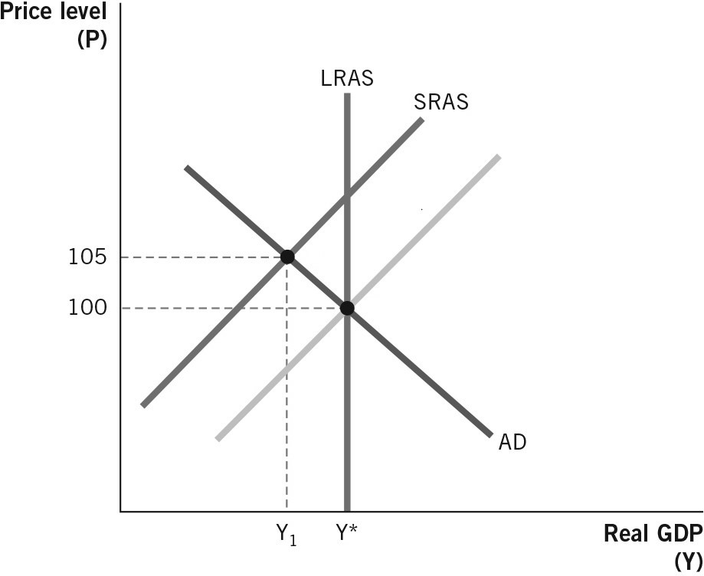

**46. In the graph above, what events might allow the economy to reach a long-run equilibrium?**

* 1. Labor costs could decrease allowing short-run aggregate supply (SRAS) to shift right.
  2. Labor costs could decrease allowing SRAS to shift left.
  3. Labor costs could decrease allowing aggregate demand (AD) to shift right.
  4. Labor costs could decrease allowing both long-run aggregate supply (LRAS) and SRAS to shift right.
  5. Labor costs could decrease allowing all three curves to shift right.

**47. How does the wealth effect explain the slope of the aggregate demand (AD) curve?**

**48. How does the interest rate effect explain the slope of the aggregate demand (AD) curve?**

**49. How does the international trade effect explain the slope of the aggregate demand (AD) curve?**

**50. What is the difference between a movement along the aggregate demand (AD) curve and** **a shift of the aggregate demand curve? Explain in terms of what causes a movement and what causes a shift.**

**51. Explain why the long-range aggregate supply (LRAS) and short-range aggregate supply (SRAS) curves are sloped differently. What are the slopes and what do the differences tell us?**

**52. Starting from long-run equilibrium, draw an aggregate demand–aggregate supply graph to illustrate the difference between a long-run and a short-run equilibrium due to an increase in aggregate demand. Once the economy is in the short-run equilibrium, explain & illustrate how long-run equilibrium will be restored.**

**53. Explain and illustrate how the long-run equilibrium levels of output and the price level are affected by a technological advance that increases labor productivity.**

**54. Explain and illustrate how the short-run and long-run equilibrium levels of output and the price level are affected by legislation that increases the employer’s cost of providing health care to workers.**